
BASSINGBOURN-CUM-KNEESWORTH PARISH COUNCIL (BKPC)

SAFEGUARDING POLICY

Purpose:
Everyone has a duty to safeguard children, young people and vulnerable adults. This policy promotes good practice in safeguarding for those engaging in any activity associated with BKPC or using its facilities. The Parish Council will review it annually. This policy applies to anyone working for or on behalf of BKPC whether in a paid, voluntary or commissioned capacity, for example contracted to do a piece of work. It also applies to any individual using the Parish Council facilities for the purpose of delivering any service to children, young people or vulnerable adults.

Definitions:
Children and young people:
- Anyone under the age of 18 years
Vulnerable Adult:
Anyone over 18 who is:
• Unable to care for themselves
• Unable to protect themselves from significant harm or exploitation
• Or may be in need of community care services

Promoting a safe environment
In order to promote a safe environment for children, young people and vulnerable adults, the Parish Council will:
• Provide safe facilities and do regular safety assessments.
• Ensure that employees, councillors and leaders of activities in / on Parish Council facilities, are aware of the safeguarding expectations.
• Ensure that the policy for users of Parish Council facilities includes a requirement that they are safe to work with children, young people and vulnerable adults (e.g. any adults who have regular unsupervised contact with children, young people or vulnerable adults during the course of their duties should undergo appropriate Disclosure and Barring Service checks).
• Ensure that attendees at functions are aware that parents are responsible for their children’s safety, and the location of a dedicated safe place for lost children is clear.
• Display on notice boards the relevant safeguarding contacts for advice and help.
Use of facilities by groups with children, young people or vulnerable adults
The Parish Council will require the leaders to:
• Have public liability insurance.
• Have a suitable safeguarding children, young people and vulnerable adult policy and/or agree to work to the Parish Council’s policy and relevant guidance.
• Ensure leaders make their members aware of the Parish Council’s Policy, and ensure that it is followed whilst using Parish Council facilities.
• Ensure leaders have valid enhanced DBS checks as appropriate, and know where the first aid box is.
• Complete risk assessments for individual activities.
Safe working practice
All users of Parish Council facilities must follow the safeguarding children, young people and vulnerable adult’s policy and procedures at all times. For example, they should:
• Never leave children, young people or vulnerable adults unattended with adults who have not been subject to a Disclosure and Barring Service (DBS) check.
• Plan activities to involve more than one person being present or at least in sight or hearing of others. Alternatively, record, or inform others of their whereabouts and intended action.
• Where possible, have male and female leaders working with a mixed group.
• Ensure registers are complete and attendees are marked in and signed out (under 8’s must be collected by a parent/carer).
• Ensure that photos or videos of individuals are not taken without written permission from parents/ carers.
• Ensure that any photos that do have permission to be taken, have separate permission for use on social media/websites.
• Ensure they have access to a first aid kit and telephone and know fire procedures.
• Ensure that where a child, young person or vulnerable adult needs assistance with toilet trips and when first aid is required, that this is carried out in pairs or in the latter case that it is carried out where they can be seen.
• When working outside, ensure activities, breaks and clothing are suitable for the weather conditions and that shelter is available where possible.
Expectations of behaviour
All users of Parish Council facilities should:
• Ensure that communications, behaviour and interaction with users should be appropriate and professional.
• Treat each other with respect and show consideration for other groups using the facilities.
• Refrain from any behaviour that involves racism, sexism and bullying, and in addition to report any instances of such behaviour to group leaders, parish councillors, the parish clerk or parents and carers, as appropriate.
What should be a cause for concern
All staff and volunteers coming in to contact with children need to have an awareness of safeguarding.
Staff and volunteers should be concerned by any action or inaction, which significantly harms the physical and/or emotional development of a child or vulnerable adult.
Abuse or neglect can take many forms:
• Neglect – the persistent lack of essential care for a child including enough love, stimulation, safety, food, clothing, shelter, medical care or education. It can also mean leaving a child alone and at risk.
• Emotional abuse – can mean repeatedly rejecting a child, constantly threatening or putting a child or young person down so that they feel unloved and worthless, children living in a home environment where there is domestic or other forms of abuse.
• Physical abuse – including hitting, punching, burning, poisoning, attempted drowning and smothering.
• Sexual abuse – forcing or persuading a child or young person to take part in any kind of sexual activity. It can include inappropriate touching, kissing or sexual intercourse. It can also involve causing a child to look at, or being involved in pornographic material or videos.
• Domestic Abuse – any incident of controlling, coercive, threatening behaviour, violence or abuse between those aged 16 or over who are, or have been, intimate partners or family members regardless of gender or sexuality. The abuse can encompass, but is not limited to: Psychological, Physical, Sexual, Financial, Emotional.
• Child Sexual Exploitation (CSE) – In February 2017, CSE was redefined as ‘a form of child sexual abuse. It occurs where an individual or group takes advantage of an imbalance of power to coerce, manipulate or deceive a child or young person under the age of 18 into sexual activity (a) in exchange for something the victim needs or wants, and/or (b) for the financial advantage or increased status of the perpetrator or facilitator. The victim may have been sexually exploited even if the sexual activity appears consensual. Child sexual exploitation does not always involve physical contact; it can also occur through the use of technology’.
• Extremism and radicalisation – signs to look out for include: Being drawn in to strong principles and ideologies held by others, as a means to control, social network involvement in extremism, being at a transitional time in life, having a need for identity, meaning and belonging, being influenced or controlled by a group, feelings of grievance and injustice, feeling under threat, displaying mental health concerns, a desire for status, a desire for excitement or adventure and/or a need to dominate and control others.
Responding to Abuse or an Allegation
If a child, vulnerable adult, or concerned party makes an allegation then the individual receiving this should:
• Reassure the person concerned.
• Listen to what they are saying.
• Remain calm and do not show shock or disbelief.
• Tell them that the information will be treated seriously.
• Ask questions to ensure that the full facts are gathered but do not start to investigate or ask detailed probing questions.
• Don’t promise to keep it a secret.
• Tell the child or adult at risk what will be done next to get help to keep him/her safe.
• Ensure that they comply with the Parish Council’s Data Protection Policy.
Recording an Allegation
Any allegations should be recorded in a timely manner:
• Use the individual’s words where possible.
• Record what they are saying.
• Record what you have been told/witnessed as soon as possible. As far as possible Parish Councillors, staff and volunteers should not deal with allegations themselves but should report the allegations to the relevant professional agency or service.
Allegations against staff and volunteers
All staff and volunteers should take care not to place themselves in a vulnerable position with a child or vulnerable adult. If an allegation is made against a member of staff or volunteer, the person receiving the allegation will immediately inform the Clerk of the Parish Council.
Whistleblowing
All staff and volunteers should be aware of their duty to raise concerns about the attitude or actions of colleagues and appropriate advice will be sought from the Cambridgeshire and Peterborough Safeguarding Partnership Board.

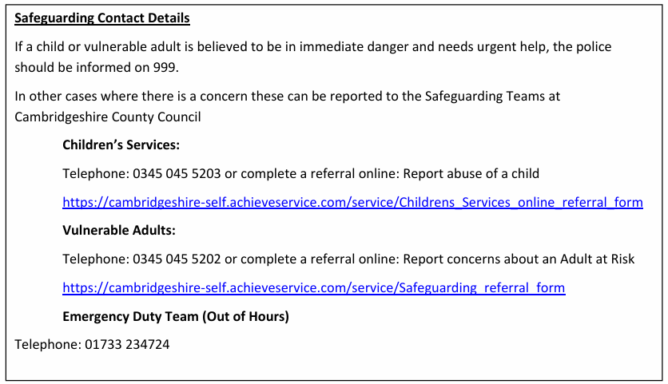

Policy Version: | V1
Policy Written by: | Maisy Pearson (Clerk)
Policy Adopted:
Minute ref:
Due for Review: | July 2027
Supersedes: | Safeguarding Policy 2025

