OSCC Outside Tap Installation
Context: Quotes have been sought by Admin Assistant to install an outside tap at the OSCC for the purpose of watering the flower cart at the front of the building.
Council have not yet resolved to install the tap but officers were asked to seek quotes in advance.
Any contractor appointed will be asked to provide evidence of public liability and other relevant insurances.
Officers ask that council consider the benefits v cost of this expenditure as well as the potential misuse of the tap and risk if tap were to be left on in freezing temps. Consider purchase of tap lock.
These quotes have been provided anonymously to avoid bias.
Quotations Received:
Quotation 1:
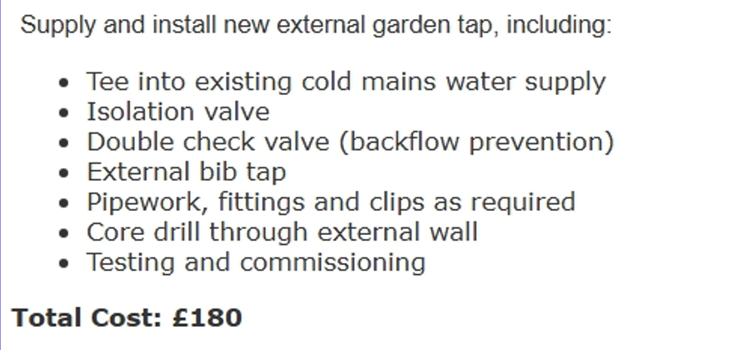
Quotation 2:
Estimate based on mains water being in the boiler room and tap being installed externally on the other side of the wall from the mains water. Includes appropriate valves, fittings and pipes to comply with water regulations.
Labour and Materials: £187.70+VAT

