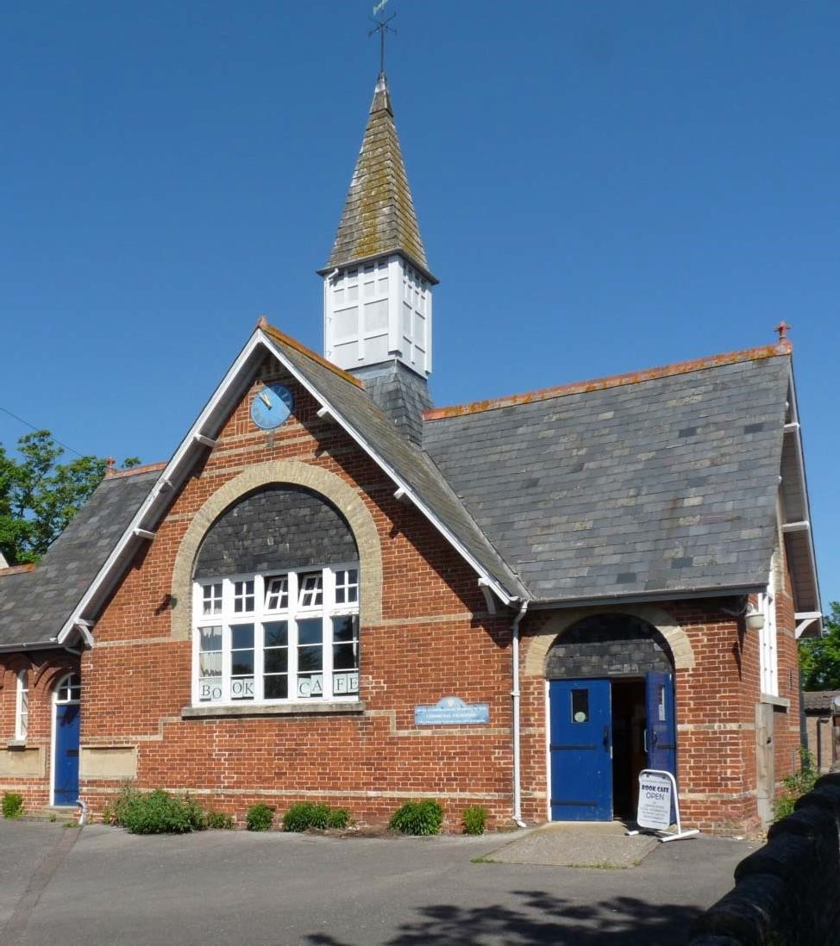

The Old School
Community Centre
Business Case

Revision 2

Table of Contents
1 EXECUTIVE SUMMARY 3
2 OBJECTIVES 4
3 BACKGROUND 5
3.1 Community Use of the OSCC 5
4 THE STRATEGIC CASE FOR A COMMUNITY CENTRE 6
4.1 Meeting the Near-Term Community Need 6
4.2 Providing a Base for the Parish Council 6
4.3 Parish Council-Controlled Local Infrastructure 6
5 OPTIONS 7
5.1 Option 1 - Continue Without Remodelling 7
5.2 Option 2 - Continue With Remodelling 8
5.3 Option 3 - Pay Up Lease and Return to SCDC 8
5.4 Options ‘Cost to Precept’ Summary 9
6 RECOMMENDATION 9
APPENDIX 1 - ASSUMPTIONS 10
APPENDIX 2 – BASELINE FOR FINANCIAL PROJECTIONS 11
APPENDIX 3 – MAINTENANCE AND REPAIR COSTS 12
APPENDIX 4 – MEETING ROOM COSTS AND OFFICE SPACE FOR COUNCIL OFFICERS 14
APPENDIX 5 – OPTION 1 (Continue Without Remodelling) 15
APPENDIX 6 – OPTION 2 (Continue With Remodelling) 16
APPENDIX 7 – OPTION 3 (Pay Up Lease and Return to SCDC) 17
APPENDIX 8 – OSCC VS OTHER BUILDINGS AVAILABLE FOR COMMUNITY USE 18
APPENDIX 9 – OPERATION, MANAGEMENT AND MARKETING OF THE OSCC 19
Organisation and Management 19
Marketing 19
APPENDIX 10 – ONGOING RISKS 20

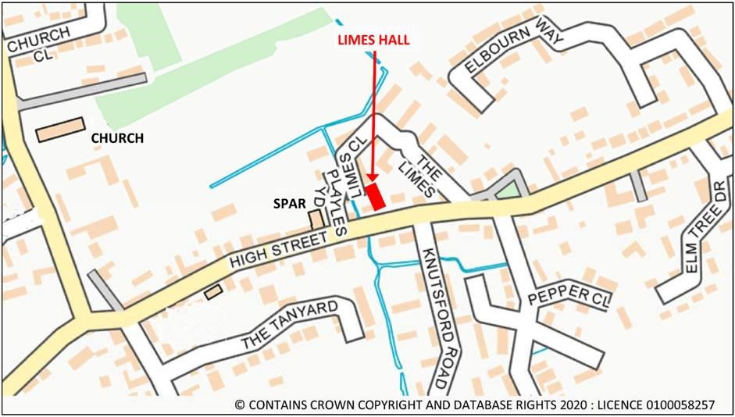
Location of the Old School Community Centre (formerly ‘The Limes’)

1 EXECUTIVE SUMMARY

The original aim of the Parish Council was to secure an enduring amenity for community activities, education, health and well-being, community development and environmental protection, and to provide a base for the Parish Council to deliver a more efficient and effective service. It secured the Old School Community Centre (OSCC) in 2022 on a 99-year lease from South Cambridgeshire District Council (SCDC) based on Revision 1 of this business case that assumed the building would move to a break-even basis over the medium term (5-7 years) following some initial funding from the precept together with increased usage.

During the first three years of operation, it has become clear that break-even cannot be achieved, with or without remodelling, and continued use of the OSCC (regarded by many in the community as a vital amenity) will need to be funded by the precept.

Revision 2 of the business case considers three options for the future of the OSCC that forecast an increase to the annual precept per household:

- Option 1 – £7.80 if the OSCC continues without any remodelling during the lease
- Option 2 – £12.10 if the OSCC continues with periodic remodelling during the lease
- Option 3 – £5.30 if the lease is terminated and the OSCC is returned to SCDC.

If the lease is terminated then no alternative location for the library has been identified, so Option 1 assumes the library would close. The same is true for the food bank and the Village Band would have to find storage space for its instruments.

The OSCC Advisory Group recommends the Parish Council adopts Option 2 at a forecast increase in precept of £12.10 per household per annum.

The OSCC Advisory Group also recommends the Parish Council prepares and approves Five-Year Plans through the lease term to break the period up into manageable blocks and enable required projects to be identified and the necessary funding secured.

Lastly, the Parish Council needs to clarify the dilapidation requirements of the lease as it is very unlikely SCDC is going to want the building returned in 96 years’ time to its current condition.

2 OBJECTIVES

The purpose of Revision 2 of the OSCC business case is, based on running the building for three full years, to:

- Extend the original financial case, that supported Council’s decision to sign the 99-year lease with South Cambridgeshire District Council, to cover the whole term of the lease. This will enable Council to budget for reserves (a sinking fund) to cover long term maintenance and repair costs.
- Enable the Council to make an informed decision about the future of the OSCC by adding two further options for consideration:
  - periodic remodelling of the building during the lease term, and
  - paying up the lease now and returning the building to SCDC.

The 99-year term of the lease enables the community centre to be an enduring village amenity that will support generations of parishioners – it is a fact of life that no one deciding on the recommendation in this business case in 2025 will be around to consider the next chapter in 2121.

The original aims for the OSCC remain the same:

- To provide a village amenity
- To enable the activities using the building while under SCDC management to continue
- To provide additional opportunities for recreation and leisure-time occupations, for the benefit of Bassingbourn-cum-Kneesworth and neighbouring Cambridgeshire villages
- To provide for the advancement of education, health and well-being, community development and environmental protection
- To support local environmental conservation and sustainable development
- To provide a base for the Parish Council clerks to enable the Council to deliver a more efficient and effective service to the community.

While the building has continued to be used by existing groups, the current layout has severely restricted its use by new groups, for ad hoc parishioner activities, or by Council clerks. There is only one room (the main hall) available for hire. The library and Parish Council meetings block-book the OSCC for much of the week and library’s mobile shelving occupies one end of the hall, reducing the available space for parties and other social activities at the weekend. Lastly, Council clerks have been unable to use anywhere in the building to perform their council duties.

As a result, although actual costs are 8% lower than originally planned, actual revenues are 48% below plan (see Appendix 2).

To increase utilisation, the OSCC Advisory Group developed ideas to remodel the building and create a multi-use room behind the kitchen (‘warm hub’) for the food bank, meetings (Council, small groups or parishioners) and Council clerk ‘hot-desking’; bespoke, less conspicuous library shelving to make the main hall amenable to a variety of uses; a smaller, modern kitchen; dedicated storage; and new toilets.

However, the cost of this remodelling was not included in the original business case, which had assumed the building would move to a break-even basis over the medium term (5-7 years) after some initial funding from the precept to smooth a transition of hiring charges to market rates together with increased usage.

It is now clear that break-even cannot be achieved, with or without remodelling, and continued use of the OSCC (regarded by many in the community as a vital amenity) will need to be funded by the precept.

3 BACKGROUND

The Old School Community Centre (OSCC), formerly known as ‘The Limes’, was established as a school in 1877 for children from Bassingbourn, Kneesworth and the surrounding villages. It continued to educate the local children until 1990 when the last of the pupils were transferred to the primary school in Brook Road. On the closure of the school, the OSCC became a facility linked to the sheltered housing behind the building and was made available for limited community use. The building contains many memories for a substantial number of local people and is part of Bassingbourn’s heritage.

Bassingbourn-cum-Kneesworth is a Minor Rural Centre with an expanding population and new houses being built. The return of military personnel to Bassingbourn Barracks is also putting pressure on village facilities.

For its size, Bassingbourn-cum-Kneesworth was unusual in not having a dedicated village hall and was substantially disadvantaged by this. There was no community focus, no central point for people to gather and inadequate accommodation for village activities. Before the OSCC, the Village College provided some facilities for the community but as times changed and school structures altered, this was lost, and a gap emerged.

3.1 Community Use of the OSCC
The OSCC has filled the gap in community facility provision. Users include:

- Sheltered housing residents
- Bassingbourn-cum-Kneesworth Parish Council
- Bassingbourn Community Library (the Book Café)
- Village Band
- Repair Cafe
- CAMTAD Hearing session
- National Childbirth Trust
- Over 60s
- Lego group
- Disaster Emergency Response Centre
- Polling Station

Bassingbourn Community Library is run by volunteers and plays a vital role in the life of our parish, offering a wide range of books for readers of all ages, a café offering drinks and snacks, and a welcoming space for all. It is part of the Cambridgeshire Library Service, who provide our library with service infrastructure and wi-fi and allow access to their wide range of services and activities, including events and workshops.

Over the last year, the library has seen an encouraging increase in usage. It had over 4,000 visitors to the library, welcomed 72 new members and issued over 5,500 books. The library gave a Duke of Edinburgh student from Bassingbourn the opportunity to do some volunteering, and currently has a volunteer from Aurora, Meldreth who attends with a carer.

Activities such as story time for preschool children, crafting for primary age children, and the Summer Reading Challenge (part of a UK wide scheme) engage the library with the local community. It also supports local book groups and provides a library-at-home service for the housebound.

The OSCC provides a venue for the Parish Council and other organisations to have their meetings and several voluntary groups, including the over 60s and CAMTAD (a hearing loss group) hold their activities there. It is where the Village Band rehearses, a small number of groups such as NCT (National Childbirth Trust) use it for their courses, and a Repair Café (part of the Cambridgeshire Repair Café Network) conducts small item repair events twice a year.

4 THE STRATEGIC CASE FOR A COMMUNITY CENTRE

The strategic case for a community centre in Bassingbourn-cum-Kneesworth has three aims: meeting the community’s near-term need for a village hall, providing a base for the Parish Council that is accessible to parishioners, and securing Parish Council-controlled local infrastructure for the future. This enables a range of social, educational and economic activities to be developed to contribute to the health and well-being of the local population over the next 96 years.

4.1 Meeting the Near-Term Community Need
There is longstanding support from the community for its own village hall, which was demonstrated both in the 2008 Parish Plan and in the 2018 Neighbourhood Plan survey. In response to the question “Tell us how you would like to see the village evolve” the answer was overwhelmingly “a Village Hall".

The Revision 1 business case assumed the OSCC would fill this gap, and in the first three years of operation existing users continued to make good use of the building (see section 3.1). However, it became clear that the current layout severely restricted its use by new groups, so the OSCC was not actively marketed, and other opportunities have not been developed yet such as:

- First aid training sessions
- District and County Councillor surgeries
- MP surgeries
- Neighbourhood Police surgeries
- Citizens Advice Bureau
- Film club
- Produce Market
- Art displays
- Children’s parties
- Men’s shed
- Craft groups

Remodelling the building to increase capacity and improve the utility of the spaces would enable the OSCC to meet the community’s near-term need (see section 5.2).

4.2 Providing a Base for the Parish Council
In the last few years, the Parish Council has modernised its organisational structure and has two clerks and a Responsible Financial Officer (RFO), all of whom currently work from home. Providing Council officers with a centrally located office space in which to work improves community access to the Council and demonstrates a growing, more influential and professional council is at work. It also provides storage space for Council records.

4.3 Parish Council-Controlled Local Infrastructure
The importance of village halls was recognised in a circular from the Department of Environment, Food and Rural Affairs dated 20th January 2020 in which Lord Gardiner, Defra Rural Affairs Minister is quoted as saying “Village halls are an essential part of rural life and that there can be no doubt that village halls are more important and relevant than ever.” Other villages locally have recognised this need and made sure that they have provided adequate facilities.

As well as being the current village hall, the OSCC provides the Parish Council with a building that it manages and controls and can use to meet the possible future needs of the community in our rapidly changing world. With the continuing reduction in public funding and County and District Councils ceasing to provide many non-statutory services, local communities will have to become increasingly self-sufficient and having control of a certain level of basic infrastructure is essential for this to be realised.

The Society of Local Council Clerks anticipated this challenge in 2018: “The devolution of services agenda is by far the biggest issue facing PCs of all sizes over the coming years. They either embrace this as an opportunity accepting that it is likely to cost more in terms of precept requirements, staffing resources and so on and bring local services in to be managed and maintained at a truly local level, or they do not embrace and allow the principle authorities to either close facilities or run them down to an unacceptable level.”

5 OPTIONS

After three years of operating the OSCC, it is appropriate to revisit the original business case to confirm if it is delivering its agreed aims for the community, if the assumptions made at the time were appropriate, and if cost and income projections are on track.

An initial review by the OSCC Advisory Group identified shortfalls in the expected amenity and utilisation of the building. In response, the group developed ideas to remodel the building and extended the original financial case to cover the whole term of the lease. From this, three options have been developed: to continue the OSCC lease but never remodel the building; to continue the OSCC lease but plan periodic remodelling during the lease term; and pay up the lease and return the building to SCDC.

5.1 Option 1 - Continue Without Remodelling
Option 1 (see Appendix 5) extends the original financial case, that supported Council’s decision to sign the 99-year lease with SCDC, to cover the whole term of the lease. It updates rental income costs based on what happened in the first two years of operation (see Appendix 2) and adds a realistic maintenance and repair schedule for the building over the lease term (see Appendix 3).

This enables Council to budget for reserves (a sinking fund) to cover long term maintenance/repair costs and agree the necessary charge to the precept to cover the revenue shortfall.

 | Total for lease (£) | Av Per Annum (£)
Revenue | 389,466 | 3,934
Cost | 1,382,335 | 13,963
Charges to Precept | 992,869 | 10,029

Option 1 is the minimum cost required to operate the OSCC for the lease term. It provides an enduring village amenity but, without any remodelling of the building, this would not deliver all the agreed aims for the community. It excludes any work to the building to meet the Council’s climate change commitment but does include replacement of the oil heating system with air source heat pumps (new oil boilers are banned from 2035) and an alternative mechanism for providing a base for the Parish Council (to improve community access to the Council – see Appendix 4).

5.2 Option 2 - Continue With Remodelling
Option 2 (see Appendix 6) builds on Option 1:

- Periodic remodelling of the building, initially to increase capacity and improve the utility of the spaces, and then to maintain utility and address future community needs
- Removes the alternative mechanism for providing a base for the Parish Council as it is included in the remodelling activity
- Periodic building enhancements to meet the Council’s climate change commitment, initially addressing the areas identified in the PECT Energy Efficiency Survey of August 2021 (except air source heat pumps, as these are already part of Option 1 due to new oil boilers being banned from 2035).

Initial remodelling of the building will create a multi-use room (‘warm hub’) for the food bank, meetings (Council, small groups or parishioners) and Council clerk ‘hot-desking’; bespoke, less conspicuous library shelving to make the main hall amenable to a variety of uses; a smaller, modern kitchen; dedicated storage; and new toilets with baby-changing facilities and disabled access.

 | Total for lease (£) | Av Per Annum (£)
Revenue | 571,451 | 5,772
Cost | 2,111,895 | 21,332
Charges to Precept | 1,540,444 | 15,560

Option 2 provides an enduring village amenity that delivers all the agreed aims for current parishioners and future generations.

Note: The current lease requires the Parish Council to reinstate all changes to the building made during the lease prior to returning the property to the landlord. This needs to be clarified with SCDC as it is very unlikely they are going to want the building returned in 96 years’ time to its current condition. No dilapidation costs are currently included.

5.3 Option 3 - Pay Up Lease and Return to SCDC
Option 3 (see Appendix 7) pays up the balance of the lease for the remaining 96 years and returns the building to SCDC. It also includes Council costs for meetings and space (with storage) for its officers to improve community access to the Council (see Appendix 4).

At the time the lease was being negotiated, the Chief Executive of SCDC advised that in the event the Parish Council did not take on the building, it would be sold and would not be available for community use. There is no reason to presume this position would change.

 | Total for lease (£) | Av Per Annum (£)
Revenue | 0 | 0
Cost | 674,520 | 6,813
Charges to Precept | 674,520 | 6,813

Option 3 does not provide an enduring village amenity. It requires existing OSCC users and Parish Council meetings to find alternative venues (listed in Appendix 8). This would not be possible for the library, and it assumes the library would close. The same is true for the food bank and the Village Band would have to find storage space for its instruments.

5.4 Options ‘Cost to Precept’ Summary
Appendices 1 to 4 list the assumptions, baseline working table, maintenance and repair costs, and alternative meeting room and Council office space costs that underpin the calculations which have been used to derive the financial projections for the three options in Appendices 5 to 7.

The average cost per annum to the precept and the resulting average cost per household per annum (assuming there are 1,290 households in the parish) for each option are:

 |  | Net Av Cost pa (£) | Av Cost per household pa (£) | Av Extra Cost pa (£) | Av Extra Cost per household pa (£)
Option 1 | Continue without remodelling | 10,029 | 7.8 | 3,216 | 2.5
Option 2 | Continue with remodelling | 15,560 | 12.1 | 8,747 | 6.8
Option 3 | Pay up lease and return to SCDC | 6,813 | 5.3

6 RECOMMENDATION

The OSCC Advisory Group recommends the Parish Council adopts Option 2 at a forecast increase in precept of £12.10 per household per annum i.e. it provides an enduring community centre for current and future generations of Bassingbourn-cum-Kneesworth parishioners using the Old School Community Centre leased from SCDC, with periodic remodelling of the building to ensure it continues to deliver its strategic aims over time.

The OSCC Advisory Group also recommends the Parish Council prepares and approves Five-Year Plans through the lease term to break the period up into manageable blocks and enable required projects to be identified and the necessary funding secured.

Lastly, the Parish Council needs to clarify the dilapidation requirements of the lease as it is very unlikely SCDC is going to want the building returned in 96 years’ time to its current condition.

APPENDIX 1 - ASSUMPTIONS

- The lease expires in 2121
- The contractual consideration is £20 per month for the duration of the lease
- The lease is fully repairing i.e. the Parish Council is liable for all maintenance/repair costs and these need to be budgeted
- The Parish Council must agree any structural changes to the building with the landlord prior to implementation
- The current lease requires the Parish Council to reinstate all changes to the building made during the lease prior to returning the property to the landlord. This needs to be clarified with SCDC as it is very unlikely they are going to want the building returned in 96 years’ time to its current condition. No dilapidation costs are currently included.
- Management, cleaning and heating requirements are estimated as a function of rental occasions based on current levels of usage
- Future revenue will be baselined on average achieved revenue (rental income, grants, donations) for first two years of operation (2022/23 and 2023/24). Revenue shortfall vs costs will be met by a charge to the precept
- Initial planned remodelling cost of £200,000 in 2025/6. Kitchen/toilets/library shelving will then be refitted for £55,000 every 25 years (in 2051, 2076 and 2101)
- Annual rental income will increase by 20% pa as a result of remodelling
- Financial modelling will be done on a flat cash basis during the duration of the lease (no inflation effect will be considered as Public Sector finances always change to match current inflation levels)
- No cost of operating the sinking fund included i.e. finance/interest charges to smooth the cashflow peaks and troughs
- The oil heating system will be replaced by air source heat pumps as new oil boilers are banned from 2035
- Initial Net Zero objectives (Roof insulation, wall insulation, double glazed windows and solar PV panels + battery) cost of £51,000 in 2026/7 (covered by a Net Zero Villages Grant) and then refitted every 25 years (in 2052, 2077 and 2102)
- Costs for air source heat pumps, improving the building fabric and solar panels are based on the PECT Energy Efficiency Survey of August 2021 as updated in the Net Zero Villages Fund request of February 2025
- There are 1,290 households in the parish
- A Parish office is required where not provided by the OSCC
- OSCC Business rates will need to be added into costs as Small Business Rate relief is only allowed on one building

APPENDIX 2 – BASELINE FOR FINANCIAL PROJECTIONS

 |  | 22/23 actual | 23/24 to  31/01/24 | 23/24 full  year | Baseline
Revenues | Rental Income | 2204 | 2455 | 2946 | 2575
Revenues | Grants /xfer reserves
Revenues | Fundraising | 892 | 1696 | 1696 | 1294
Revenues | Donations | 100 | 30 | 30 | 65
Revenues | Charges to the Precept
Revenues | Other Income
Total revenue + CUM |  | 3196 |  | 4672 | 7868
Revision 1 Plan Revenues + CUM ⁽¹⁾ |  | 6140 |  | 8876 | 15016
 | Variation to Plan £ |  |  |  | 7148
 | Variation to Plan % |  |  |  | -48%
Costs | Electricity | 2451 | 1598 | 1917.6 | 2184
Costs | Oil | 2092 | 715 | 858 | 1475
Costs | Water | 101 |  | 101 | 101
Costs | Rates | 1622 | 1703 | 1703 | 1663
Costs | Rent | 237 |  |  | 237
Costs | Day to Day building maintenance | 212 | 336 | 403.2 | 308
Costs | Cleaning | 1432 | 1261 | 1513.2 | 1473
Costs | Administration
Costs | Remodelling costs
Costs | Consumables | 109 | 321 | 385.2 | 247
Costs | Premises checks | 175 | 677 | 812.4 | 494
Costs | Full Repairing Fund | 2000 | 2000 | 2000 | 2000
Costs | Net Zero objectives
Costs | Other costs |  | 440 | 528 | 264
Total Cost + CUM |  | 10431 |  | 10221.6 | 19448
Revision 1 Plan Costs + CUM ⁽¹⁾ |  | 11760 |  | 9465 | 21225
 | Variation to Plan £ |  |  |  | 1772
 | Variation to Plan % |  |  |  | 8%

Notes: ⁽¹⁾ Offset by one year as lease signed a year later than assumed in Revision 1 business case

APPENDIX 3 – MAINTENANCE AND REPAIR COSTS

old school Repairing cost estimate assuming we don’t rent the building commercially which would require more frequent renewal of various items
 | Cost £k | Rationale | Times during lease | £k impact
Replace Boiler with air source heat pump units | 29 | PECT report estimates heat pump installation cost £25k in 2021. Add 15% for product cost increase. Service life of a heat pump is 25 years | 4 | 116
Increase in heating costs | 0 | Business electricity 24.36 to 34.91 pence per kWh (av 29.64); oil price 4.81 to 10p per kWh (av 7.41) ie electricity is 4 times more expensive. Heat pumps COP of 4 now being achieved (1 kW of input generates 4 kW of heat). This will raise cost of heating by factor of 4/4 ie 1 (or no increase). | 0 | 0
Replace radiators suitable for ASHP | 5 | 4 x 10,000 BTU radiators cost £400 each for the main hall; 8 x 1,500 BTU radiators £200 each for rest of building; 4 days plumber @£400pd  Service life of radiators is 30 years – replace at 25 years in line with ASHP | 4 | 20
Re-wire building and make good | 25 | Modern wiring can serve safely for 25-40 years. Assume replace every 35 years; current wiring is over 20 years old | 3 | 75
Re paint outside woodwork | 18 | Painting woodwork has a 10-year maximum service life if not exposed to direct sunlight / frost. We know it costs £18K as it has just been done: assume we can stretch the lifetime and need to do this at least 7 times during the lease. all woodwork will need to be replaced at least once during the lease | 7 | 126
Re-decorate inside | 20 | Once every 40 years as a minimum | 2 | 40
Replace plumbing, hot and cold-water tanks, make good | 20 | Public usage building would require every 15 years but OSCC will be little used by comparison – replace every 50 years. None not done in the last 20 years | 2 | 40
Replace all exterior doors and windows | 45 | Once every 100 years these will need changing and painting a number of times during installation Assume we can refit wood - otherwise plastic doors and windows only last 20 years as a maximum | 1 | 45
Replace / refurbish roof | 75 | Once every 75 years - that's the service life. The roof has had no repairs for at least 20 years. Cost range c£65K for replacing rainwater layers but could double if all supporting woodwork and facias require replacement (some will) | 1 | 75
Replace rainwater goods | 25 | Once every 50 years and the current rainwater goods are at least 20 years old.  Assume done at the same time as the roof to minimise scaffolding costs | 2 | 50
Replace building flooring | 30 | Wooden flooring is the most durable and has a service life of 25-30 years. Assume with little usage, the floor will last 50 years. Current flooring is over 20 years old | 2 | 60
Resurface external grounds | 25 | Once every 100 years | 1 | 25
Repoint exterior brickwork | 35 | Once every 75 years | 1 | 35
 |  |  |  | £k impact
Total sinking fund |  |  |  | 707
Annual budget assigned |  | This should be used in the business plan |  | 7.14

APPENDIX 4 – MEETING ROOM COSTS AND OFFICE SPACE FOR COUNCIL OFFICERS

If PC has to hire alternate rooms for meetings
Bassingbourn church rooms | £/hour Hours | Number Cost/year
Bassingbourn church rooms | 8 | £
3 council meetings a month | 8 2 | 36 576
HR meet every other month | 8 1 | 6 48
annual meeting 1 per year | 8 3 | 1 24
Pavilion Trustees meet 4/year | 8 2 | 4 64
exceptional meetings | 8 2 | 3 48
exceptional meetings | Annualised cost | 760

Office space for Council officers

Annual rent and rates for a small office in the village are about £300/m² pa
Assume 20m area
ie £6,000 pa (or £576,000 over 96 years)

APPENDIX 5 – OPTION 1 (Continue Without Remodelling)

Current Plan NO change to Building |  |  |  |  |  |  | Financial Years
 |  |  | Baseline | 25/26 | 26/27 | 27/28 | 28/29 | 29/30 | 2031-40 | 2041-2121 | Total for lease
 | REVENUE | Rental Income | 2575 | 2575 | 2575 | 2575 | 2575 | 2575 | 25750 | 216300 | 254925
 |  | Grants | 0 |  |  |  |  |  |  | 0 | 0
 |  | Fundraising | 1294 | 1294 | 1294 | 1294 | 1294 | 1294 | 12940 | 108696 | 128106
 |  | Donations | 65 | 65 | 65 | 65 | 65 | 65 | 650 | 5460 | 6435
 |  | Charges to the Precept | 7711 | 10211 | 10211 | 10211 | 10211 | 10211 | 102108 | 839707 | 992869
 |  | Other Income | 0 | 0 | 0 | 0 | 0 | 0 | 0 | 0 | 0
 |  | TOTAL | 11645 | 14145 | 14145 | 14145 | 14145 | 14145 | 141448 | 1170163 | 1382335
 | COST | Electricity | 2184 | 2184 | 2184 | 2184 | 2184 | 2184 | 21843 | 183481 | 216246
 |  | Oil | 1475 | 1475 | 1475 | 1475 | 1475 | 1475 | 14750 | 123900 | 146025
 |  | Water | 101 | 101 | 101 | 101 | 101 | 101 | 1010 | 8484 | 9999
 |  | Rates | 1663 | 1663 | 1663 | 1663 | 1663 | 1663 | 16625 | 139650 | 164588
 |  | Rent | 237 | 237 | 237 | 237 | 237 | 237 | 2370 | 19908 | 23463
 |  | Day to Day building maintenance | 308 | 308 | 308 | 308 | 308 | 308 | 3076 | 25838 | 30452
 |  | Cleaning | 1473 | 1473 | 1473 | 1473 | 1473 | 1473 | 14726 | 123698 | 145787
 |  | Administration
 |  | Remodelling costs | 0 |  |  |  |  |  |  |  | 0
 |  | Consumables | 247 | 247 | 247 | 247 | 247 | 247 | 2471 | 20756 | 24463
 |  | Premises checks | 494 | 494 | 494 | 494 | 494 | 494 | 4937 | 41471 | 48876
 |  | Full Repairing Fund | 2000 | 7140 | 7140 | 7140 | 7140 | 7140 | 71400 | 599760 | 706860
 |  | Net Zero objectives | 0 |  |  |  |  |  |  |  | 0
 |  | Other costs / Council office | 264 | 6264 | 6264 | 6264 | 6264 | 6264 | 62640 | 508176 | 602136
 |  | TOTAL | 11645 | 14145 | 14145 | 14145 | 14145 | 14145 | 141448 | 1170163 | 1382335

APPENDIX 6 – OPTION 2 (Continue With Remodelling)

Continue with remodelling changes and complete in 25/26 |  |  |  |  |  |  | Financial Years
 |  |  | Baseline | 25/26 | 26/27 | 27/28 | 28/29 |  | 29/30 | 2031-40 | 2041-2121 | Total for lease
 | REVENUE | Rental Income | 2575 | 3090 | 3090 | 3090 | 3090 |  | 3090 | 30900 | 259560 | 305910
 |  | Grants | 0 | 80000 | 51000 |  |  |  |  |  | 0 | 131000
 |  | Fundraising | 1294 | 1294 | 1294 | 1294 | 1294 |  | 1294 | 12940 | 108696 | 128106
 |  | Donations | 65 | 65 | 65 | 65 | 65 |  | 65 | 650 | 5460 | 6435
 |  | Charges to the Precept | 7711 | 131137 | 11137 | 11137 | 11137 |  | 11137 | 111358 | 1253406 | 1540444
 |  | Other Income | 0 | 0 | 0 | 0 | 0 |  | 0 | 0 | 0 | 0
 |  | TOTAL | 11645 | 215586 | 66586 | 15586 | 15586 |  | 15586 | 155848 | 1627122 | 2111895
 | COST | Electricity | 2184 | 2184 | 2184 | 2184 | 2184 |  | 2184 | 21843 | 183481 | 216246
 |  | Oil | 1475 | 1475 | 1475 | 1475 | 1475 |  | 1475 | 14750 | 123900 | 146025
 |  | Water | 101 | 101 | 101 | 101 | 101 |  | 101 | 1010 | 8484 | 9999
 |  | Rates | 1663 | 1663 | 1663 | 1663 | 1663 |  | 1663 | 16625 | 139650 | 164588
 |  | Rent | 237 | 237 | 237 | 237 | 237 |  | 237 | 2370 | 19908 | 23463
 |  | Day to Day building maintenance | 308 | 308 | 308 | 308 | 308 |  | 308 | 3076 | 25838 | 30452
 |  | Cleaning | 1473 | 1473 | 1473 | 1473 | 1473 |  | 1473 | 14726 | 123698 | 145787
 |  | Administration
 |  | Remodelling costs | 0 | 200000 |  |  |  |  |  |  | 165000 | 365000
 |  | Consumables | 247 | 247 | 247 | 247 | 247 |  | 247 | 2471 | 20756 | 24463
 |  | Premises checks | 494 | 494 | 494 | 494 | 494 |  | 494 | 4937 | 41471 | 48876
 |  | Full Repairing Fund | 2000 | 7140 | 7140 | 7140 | 7140 |  | 7140 | 71400 | 599760 | 706860
 |  | Net Zero objectives | 0 | 0 | 51000 | 0 | 0 |  | 0 | 0 | 153000 | 204000
 |  | Other costs | 264 | 264 | 264 | 264 | 264 |  | 264 | 2640 | 22176 | 26136
 |  | TOTAL | 11645 | 215586 | 66586 | 15586 | 15586 | 15586 |  | 155848 | 1627122 | 2111895

APPENDIX 7 – OPTION 3 (Pay Up Lease and Return to SCDC)

Pay up the lease NOW and return to SCDC |  |  |  |  |  |  | Financial Years
 |  |  | Baseline | 25/26 | 26/27 | 27/28 | 28/29 | 29/30 | 2031-40 | 2041-2121 | Total for lease
 | REVENUE | Rental Income | 2575 | 0 | 0 | 0 | 0 | 0 | 0 | 0 | 0
 |  | Grants | 0 | 0 |  |  |  |  |  | 0 | 0
 |  | Fundraising | 1294 | 0 | 0 | 0 | 0 | 0 | 0 | 0 | 0
 |  | Donations | 65 | 0 | 0 | 0 | 0 | 0 | 0 | 0 | 0
 |  | Charges to the Precept | 7711 | 30040 | 6760 | 6760 | 6760 | 6760 | 67600 | 549840 | 674520
 |  | Other Income | 0 | 0 | 0 | 0 | 0 | 0 | 0 | 0 | 0
 |  | TOTAL | 11645 | 30040 | 6760 | 6760 | 6760 | 6760 | 67600 | 549840 | 674520
 | COST | Electricity | 2184 | 0 | 0 | 0 | 0 | 0 | 0 | 0 | 0
 |  | Oil | 1475 | 0 | 0 | 0 | 0 | 0 | 0 | 0 | 0
 |  | Water | 101 | 0 | 0 | 0 | 0 | 0 | 0 | 0 | 0
 |  | Rates | 1663 | 0 | 0 | 0 | 0 | 0 | 0 | 0 | 0
 |  | Rent | 237 | 23280 | 0 | 0 | 0 | 0 | 0 | 0 | 23280
 |  | Day to Day building maintenance | 308 | 0 | 0 | 0 | 0 | 0 | 0 | 0 | 0
 |  | Cleaning | 1473 | 0 | 0 | 0 | 0 | 0 | 0 | 0 | 0
 |  | Administration
 |  | Remodelling costs | 0 |  |  |  |  |  |  |  | 0
 |  | Consumables | 247 | 0 | 0 | 0 | 0 | 0 | 0 | 0 | 0
 |  | Premises checks | 494 | 0 | 0 | 0 | 0 | 0 | 0 | 0 | 0
 |  | Full Repairing Fund | 2000 | 0 | 0 | 0 | 0 | 0 | 0 | 0 | 0
 |  | Net Zero objectives | 0 |  |  |  |  |  |  |  | 0
 |  | Other costs / meeting room hire / Council office | 264 | 6760 | 6760 | 6760 | 6760 | 6760 | 67600 | 549840 | 651240
 |  | TOTAL | 11645 | 30040 | 6760 | 6760 | 6760 | 6760 | 67600 | 549840 | 674520

APPENDIX 8 – OSCC VS OTHER BUILDINGS AVAILABLE FOR COMMUNITY USE
Building | Benefits | Constraints | Suitable for library | Suitable for Village Band | Suitable for Parish Council
The OSCC | See main text | See main text | Yes | Yes | Yes
Parish Church | Large space | Availability for all PC meetings | No | No storage space for instruments | No office space
Church Room | Good availability Moderate cost | Small size | No | No storage space for instruments | Too small for main PC meeting.  No office space.
Knutsford Road facility |  | Casual layout with soft furnishings unsuitable for many activities | No | No storage space for instruments | Unsuitable layout.  No office space
Pavilion | In Parish Council ownership | Only access is across grass and unlit  Difficult for disabled | No | No storage space for instruments | No office space
Sports Centre | Large space | Layout for sports only  Only available for block bookings | No | No storage space for instruments | Availability uncertain.  No office space
United Reform Church | Moderate cost | Constricted layout in room usually offered | No | No storage space for instruments | No office space
Bassingbourn  Village College | Large main hall | Often not available  (exams, holidays)  More expensive than other options | No | No storage space for instruments | No office space

APPENDIX 9 – OPERATION, MANAGEMENT AND MARKETING OF THE OSCC

Organisation and Management
Operating and managing the OSCC will require sufficient time and experience from the clerk and RFO. Where they don’t exist, procedures for day-to-day/monthly/annual/periodic operations, maintenance and inspections will need to be developed. A review of the Brown & Lee building survey of June 2020 should be undertaken and the recommendations that remain outstanding actioned/scheduled.
Once the initial remodelling of the OSCC has been completed, the Parish Records will be stored in a cupboard accessed from the ‘warm hub’. The clerk and the RFO will ‘hot desk’ in that area, increasing access to them for the public and councillors that will make for a more efficient and responsive council.

Marketing
The current layout of the OSCC severely restricted use of the OSCC by new groups and for ad hoc parishioner activities. As a result, actual income in the first two years of operation was 48% below plan. Proposed remodelling works are designed to make the building more suitable for hiring and increase capacity. However, there are other buildings available for community use (see Appendix 8) and the Parish Church is undergoing its own remodelling that could position its room as a direct competitor with the main hall.
As a result, the existing marketing of the building (advertising in the Village Voice and in the Royston Listings, event posting on the five village notice boards, the page on the Parish Council website and social media posts) needs to be reviewed, restructured and then actively monitored and managed.

APPENDIX 10 – ONGOING RISKS

 | RISK | CONSEQUENCE | UNMITIGATED RISK | MITIGATION
1 | Competition with other buildings available for community use in the village | Hire rates are squeezed and become uneconomic | Medium to high | The current layout severely restricted use of the OSCC by new groups and for ad hoc parishioner activities. As a result, actual income in the first two years of operation was 48% below plan. Proposed remodelling works are designed to make the building more suitable for hiring and increase capacity. However, the Parish Church is undergoing its own remodelling that could position its room as a direct competitor with the main hall.  An updated analysis of competing buildings is required and active marketing of the OSCC by the Parish Council is necessary
2 | Lease requirement to reinstate any changes at end of term remains in place | Substantial dilapidation costs at lease end | Very low | SCDC agrees to update reinstatement clause such that remodelling and Net Zero initiatives, which they have to approve anyway, are considered as “original condition”.
3 | Building condition issues (particularly related to the roof) are uncovered during remodelling or Net Zero initiative work | Substantial remedial expenditure (in excess of £100k) | Low | Build good working relationship with SCDC eg during lease dilapidation discussions, early stages of remodelling work and brief them of the social value of the building and the proposed improvements using this document
4 | The building is allowed to deteriorate during the course of the lease | Substantial repair expenditure  Costs exceed budget | Very low as long as any repairs are carried out promptly | An inspection should be carried out every year in early autumn on the roof, gutters etc to ensure no water penetration and a detailed inspection carried out every 4 years
5 | Parking proves to be a major issue | Loss of goodwill from residents  Potential restriction on activities | Very low | Parking is not allowed in the sheltered scheme (the OSCC and Limes Close). There is provision in Knutsford Rd, Spring Lane and the High St but an “audit” should be carried out of nearby parking provision and provision for any larger events considered (e.g. an arrangement with The Hoops).
6 | Riotous & unruly behaviour by users | Loss of goodwill from residents  Potential restriction on activities | Very low as long as managed | Groups using the OSCC need to be managed and booking conditions enforced for non-regular users
7 | Damage to the building by user groups | Unexpected costs for repair | Low risk but manageable | Make clear that the user group is responsible for any damage and a deposit obtained in certain cases
8 | The building is poorly managed | Loss of income and loss of goodwill  Costs may exceed budget | Very low | A management committee needs to be established with committed and experienced members with clear lines of reporting to PC
9 | Poor administration | Costs may exceed budget | Very low | A booking system has been set up and a bookkeeping system established with regular bank reconciliations and hire income reconciliations.  Annual audit needs to be considered
10 | Costs prove to be significantly greater than anticipated | Costs may exceed budget | Low | Actual costs in the first two years of operation were 8% lower than budget. Costs should be analysed and reviewed each year, and budgets adjusted appropriately in the Five Year Plan.  Grants / fund-raising may need to be considered
11 | The legislative environment changes making it more difficult to run village halls | Reduced scope of operation with adverse impact on costs | Low | All major parties have given support to local groups running facilities such as The Old School Community Centre and this is unlikely to change
12 | Expectations of rental income prove to be too optimistic | Costs may exceed budget | Low | Actual income in the first two years of operation was 48% below plan. Revenue budgets in Revision 2 of the business case have been adjusted accordingly. Revenue achieved should be analysed and reviewed each year, and budgets adjusted appropriately in the Five-Year Plan.  Understand Litlington and Whaddon accounts (both much smaller than Bassingbourn) that initially indicated gross income comfortably in excess the Revision 1 business plan estimates.  Review/move rental rates in line with other local venues.  Improve marketing of the OSCC
13 | Major external “act of god” event causes considerable damage to the building at some stage during the life of the lease especially arising from climate change | Financial | Low to medium | The risks are insurable, and care needs to be given to the terms of the insurance to ensure that all risks are covered  There is a small stream adjacent to the headmaster's house, but it has not created a flooding problem in the past. The building is one of the tallest in the village and a lightning conductor may be beneficial to  mitigate against storms  After mitigation, the major residual uninsurable risk is low
14 | Loss of people from village hall organization | Inability to operate the building as a village hall | Medium | Ensure strongly constituted village hall committee with members from the village hall and the community

