Hemlock
Context: Potential Hemlock has been identified at Willmott Recreation Ground, BKPC were notified by residents
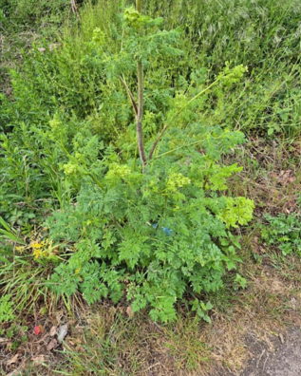

Multiple plants have been identified and council need to consider action to remove.
Cllr Orchiston has done some additional research and reported the following article:
Hemlock advice | Peterborough City Council

